**Multimedia Information Retrieval - Homework 3**

**Name:** Filipe Fernandes Miranda **Student Number:** s1780581

**Answer 1**

The program executes as expected besides a small anomaly: when running the program using the command: “./webspider <http://leidenuniv.nl>” the program stops for several seconds when trying to connect to the url: “https://sapepp.leidenuniv.nl/irj/portal/” . In my opinion this happens because needs some kind of authorization to access it or the link is not working well.

I wrote this code with my colleague Filipe Daniel da Gama Batista.

Program running:

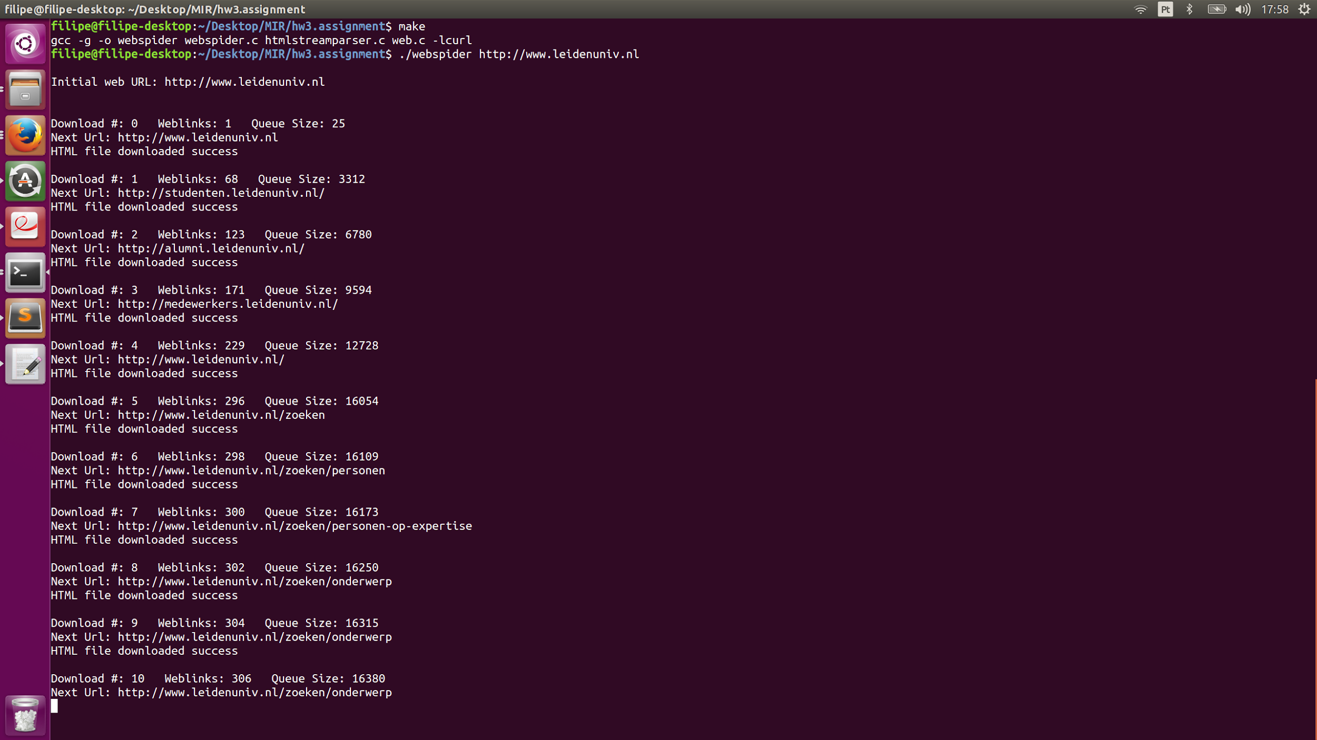

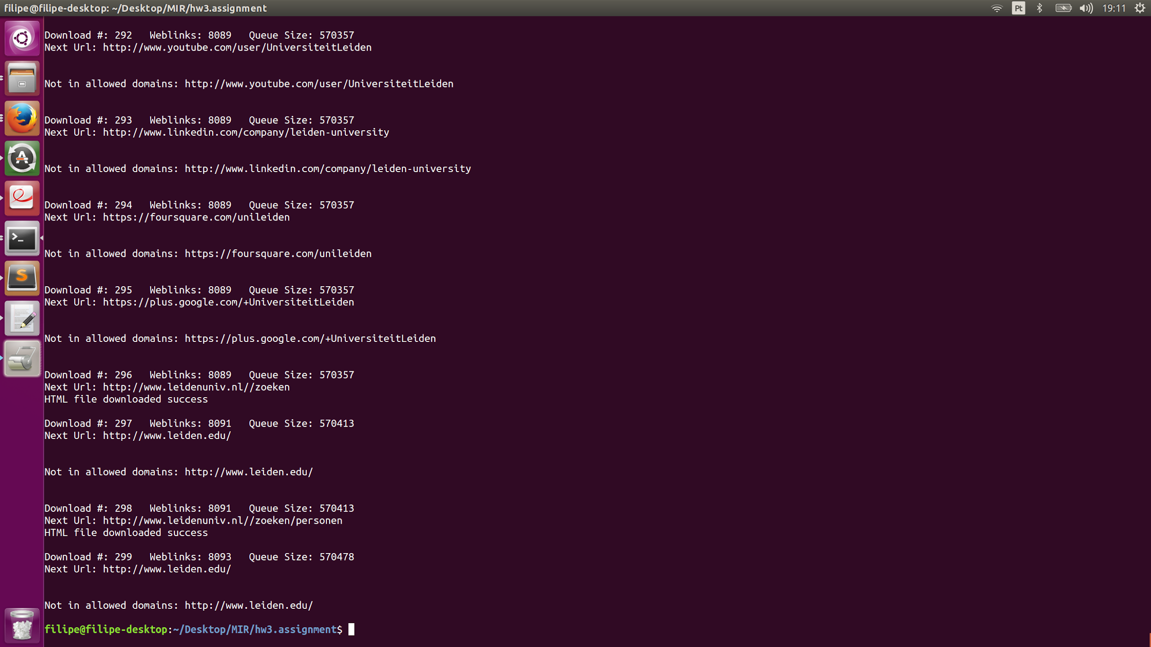

The program can halso handle error input:

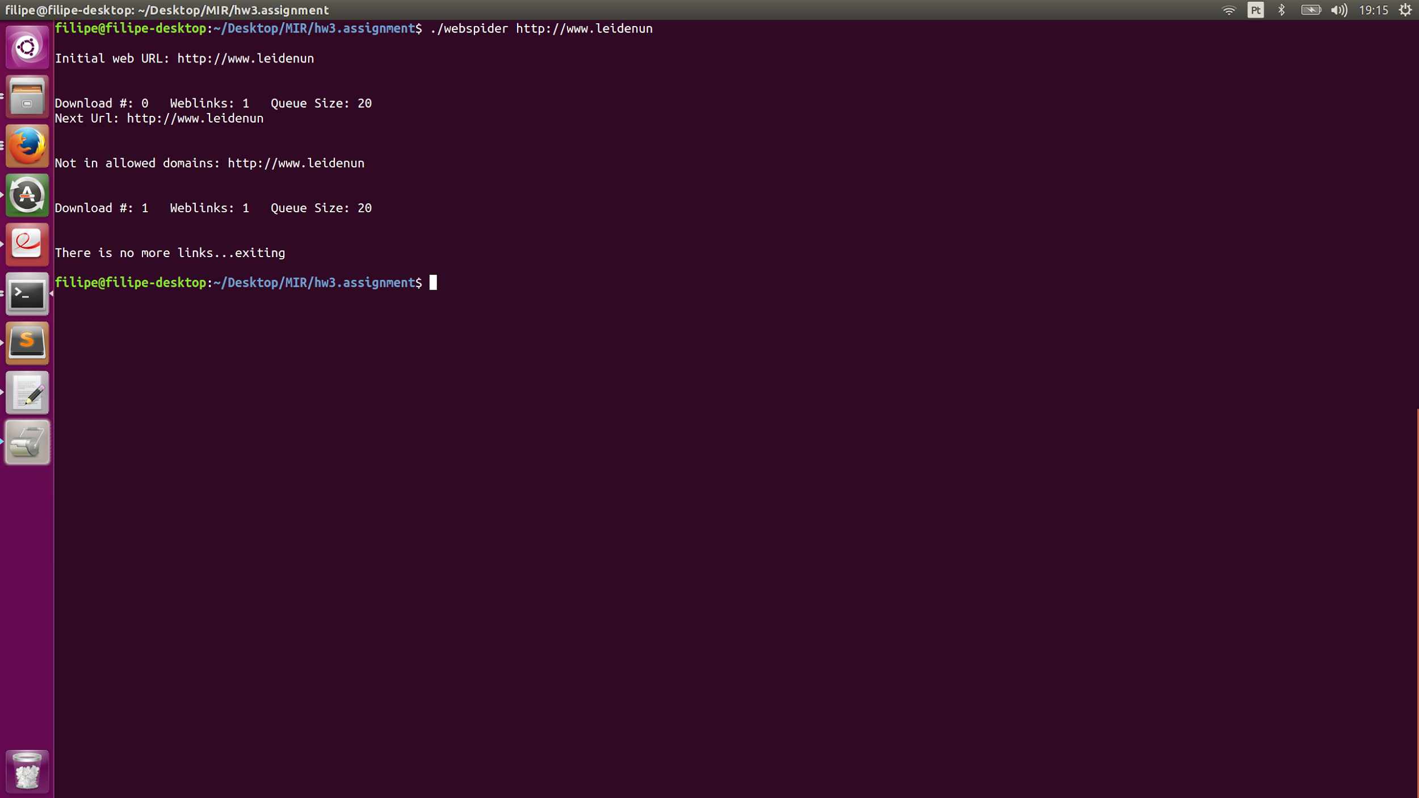

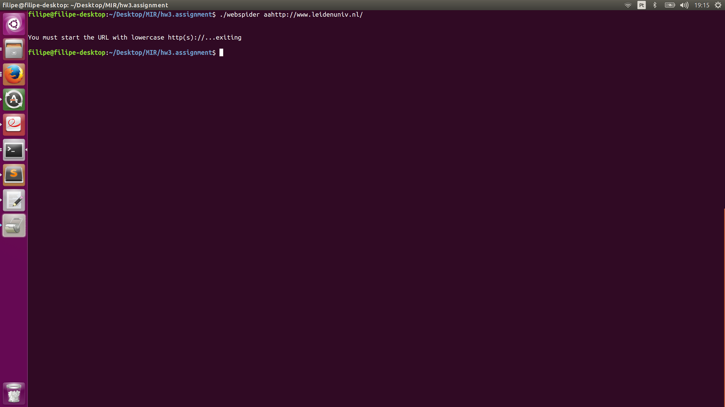

**Answer 2**

To avoid duplication we would have to implement a data structure that was both low on memory and had a good search time.

The best way to avoid duplication in our program would be to index the URL’s in an Hash Table. An Hash Table is a data structure that associates a value to a unique key using an hash function. This structure is preferable once it has an order of insertion, deletion and search of value one and space usage of order n members.

The orders of the hash table are far better than other data structures like trees and heaps that have O(k) and O(n) orders of search respectively.

To avoid duplication and using Hash Tables, the program would just have to check if an URL is already indexed in our table and ignore it if already is or insert it if not.

A disadvantage of using Hash Tables is the probability of collisions in hashing the urls if we don’t know how many there will be. If we build a small

**Answer 3 a)**

Analyzing the result images, I think that the salient points are found very often because they have high-contrast regions, which helps the program find salient points, and ,with that, find the edges of the “objects”.

The most predominant salient points found were on the towers, windows and doors of the chapel. With that we can say that it found the most important aspects of the building.

The second image appears to have more salient points then the first one regarding the chapple, perhaps because is closer, and consequently has more pixels to analyze and generate salient points from.

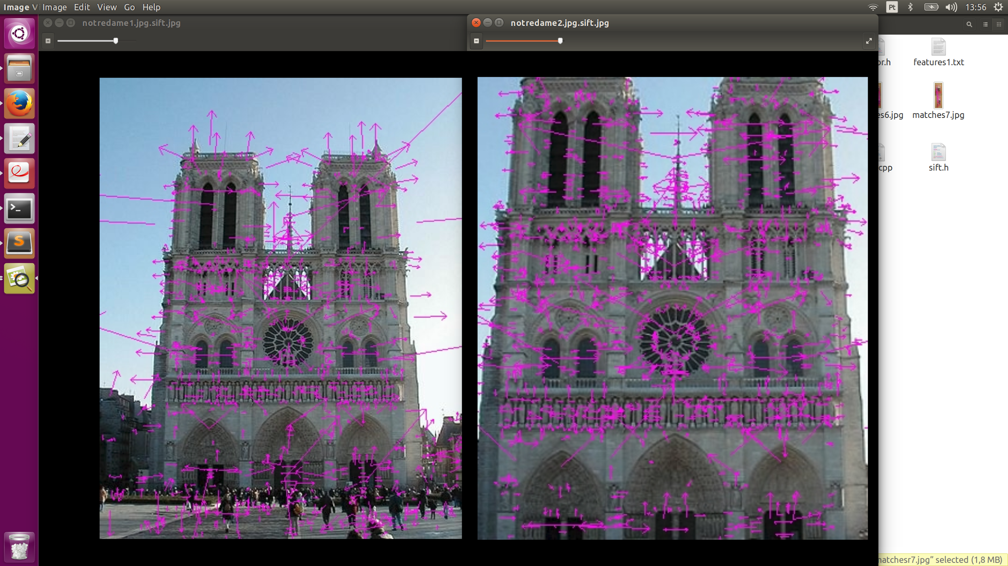

**Answer 3 b)**

After running the program using the two images of Tom Cruise, we can say that the salient point detector is not accurate. This might be explain by the lack of contrast in the images and sharpness in the “objects” part of the image (the face does not present much contrast in this light conditions, besides the wrinkles and the lips, nor does present sharpness or contour for the program to process).

Images obtained by running the program (matches and matches after RANSAC):

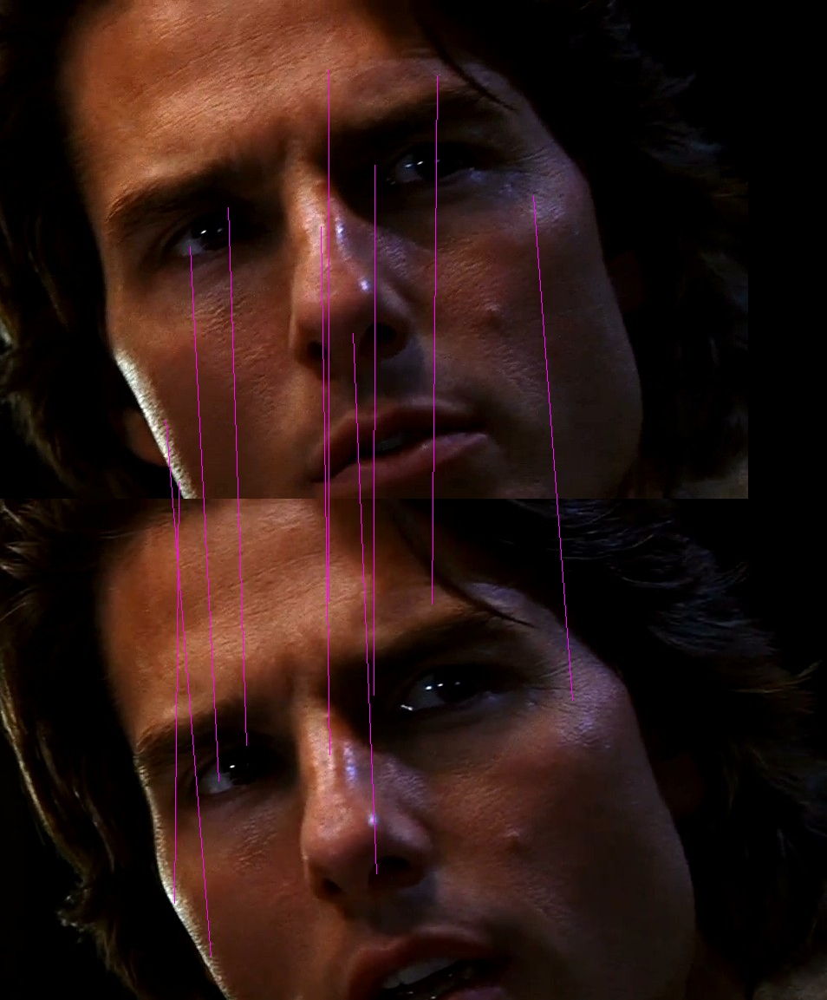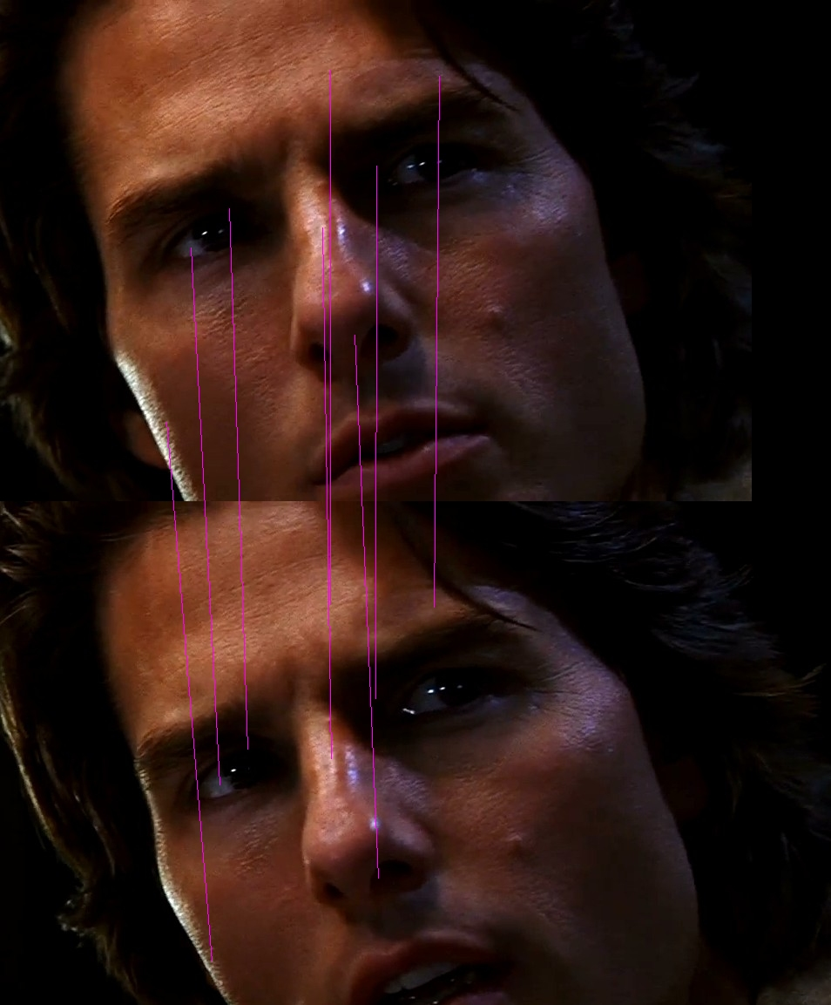

**Answer 3 c)**

Using a photo of a magazine in seven different angles we can see the number of matches between the photo of 0 degrees of inclination and the others (10º, 20º, 30º, 40º, 50º, 60º and 70º) decreases dramatically along the angles.

|  |  |  |  |
| --- | --- | --- | --- |
| Angle of the pictures (º) | No of features | Matches | Matches After RANSAC |
| 0º | 3202 | - | - |
| 10º | 2412 | 994 | 865 |
| 20º | 2603 | 1028 | 901 |
| 30º | 2763 | 907 | 796 |
| 40º | 2973 | 803 | 688 |
| 50º | 4566 | 557 | 478 |
| 60º | 2789 | 193 | 150 |

Although the simple matches and the RANSAC matches do not have the same values, they follow the same trend of decreasing as the angle increases. This decrease is most notable between the image of 50º to the image of 60º.

Sequence of images of comparisons between the “original” photo and the others with the matches marked in pink:

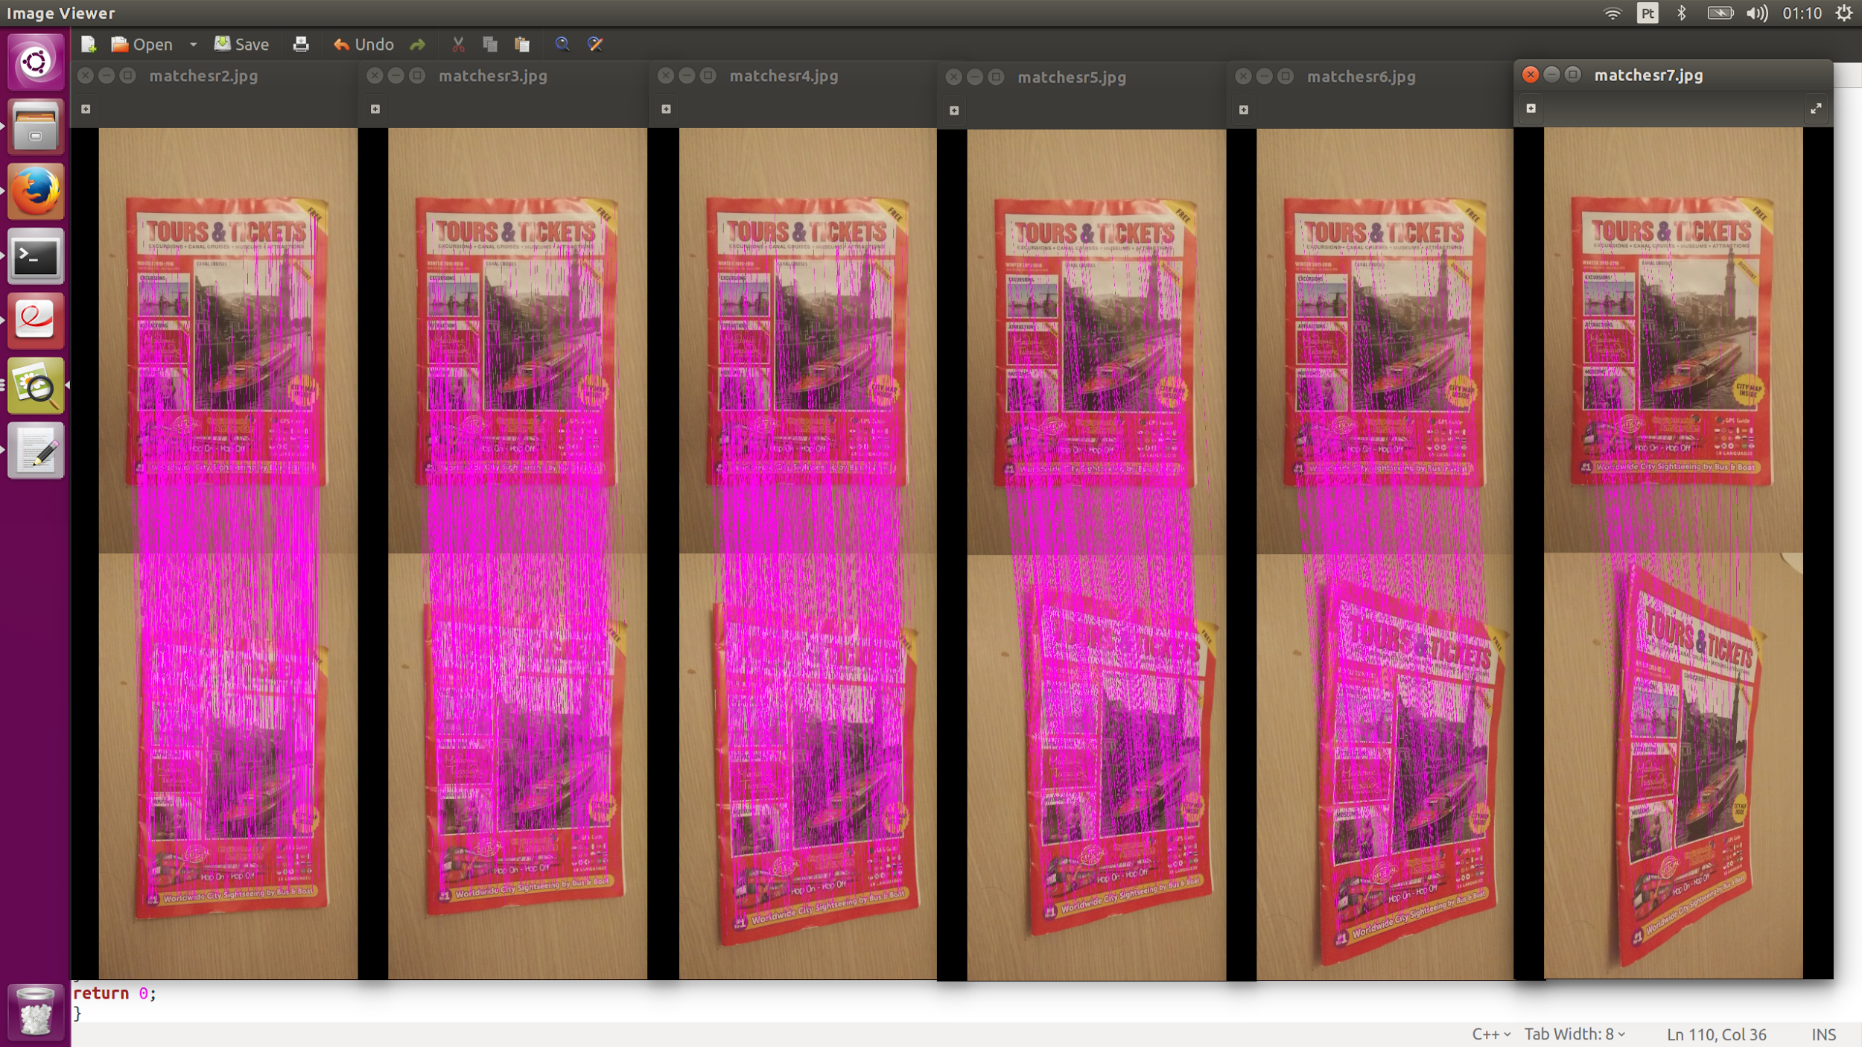

**Answer 3 d)**

The program works as expected. I t can receive more than three arguments also (for examples, if it receives five images, will compare the first with the other four).

Example with three arguments:

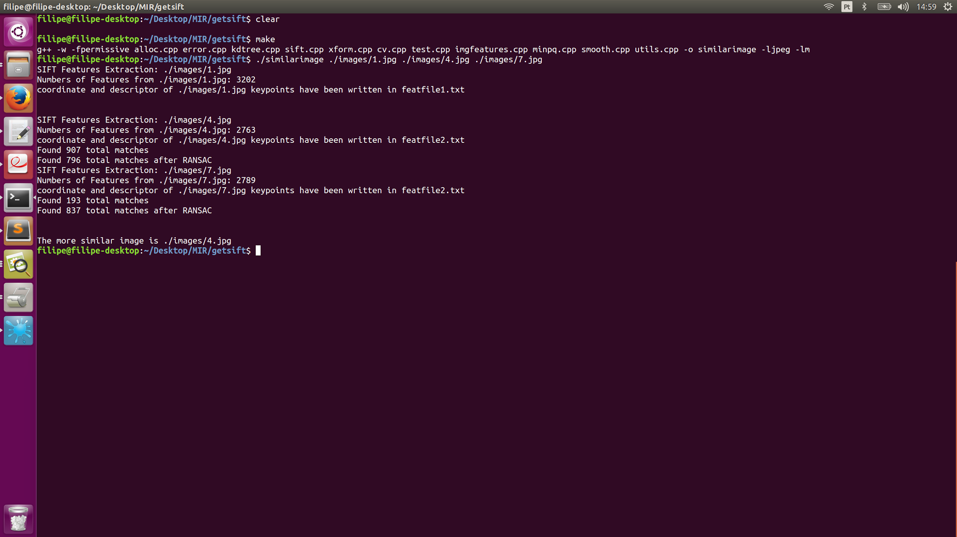

Example with five arguments:

